**Silesian University of Technology**

**Hierarchical Control Lab-2**

**Title of the exercise:**

|  |
| --- |
| “Oil refinery”  **Date of the exercise:**  08.11.2013 |

**Group Students:**

Ismail Kalay

Aiganym  Kadrina

**Introduction:**

In this lab, we were supposed to create a program solving the optimization problem for oil refinery. Its goal is to maximize the profit of the refinery. The reﬁnery buys oil from 3 diﬀerent delivers and sales 9 diﬀerent products.

**Matlab Codes:** clc;clear all;

k2=0.02;k3=0.03;k4=0.04;k5=0.05;k6=0.06;k7=0.07;k8=0.08;

i0=0.10;i1=0.11;i2=0.12;i4=0.14;i5=-0.15;i6=0.16;ub = inf(20,1);lb = zeros(20,1);

% spo sdo sho sca scb scc scd sg sp do1 do2 do3 cpo cdo cho uo1 uo2 uo3 udc ucc

C=[1.8 4.0 4.2 4.3 4.2 4.1 4.0 3.3 5.5 -1.8 -1.9 -2 -i6 -0.21 -0.21 0 0 0 0 0];

C=transpose(C);

A=[0 0 0 0 0 0 0 0 0 1 0 0 0 0 0 1 0 0 0 0;

0 0 0 0 0 0 0 0 0 0 1 0 0 0 0 0 1 0 0 0;

0 0 0 0 0 0 0 0 0 0 0 1 0 0 0 0 0 1 0 0;

0 0 0 0 0 0 0 0 0 1 1 1 0 0 0 0 0 0 1 0;

0 0 0 0 0 0 0 0 0 0 0 0 1 1 1 0 0 0 0 1;

0 0 0 0 0 0 0 -1 i5 k2 k3 k4 i2 i6 i4 0 0 0 0 0;

0 0 0 -1 0 0 0 -1 -i0 k2 k2 k3 k6 i2 i0 0 0 0 0 0;

0 0 0 0 -1 0 0 0 -0.25 k3 k4 k5 k4 k4 k4 0 0 0 0 0;

0 0 0 0 0 -1 0 0 -0.3 k4 k5 k8 0.4 0.2 0.3 0 0 0 0 0;

0 0 0 0 0 0 -1 0 -0.2 k4 k6 k5 k6 0.28 0.3 0 0 0 0 0;

0 0 1 0 0 0 0 0 0 -0.1 -k7 -i4 0.6 -0.2 1 0 0 0 0 0;

0 1 0 0 0 0 0 0 0 -0.2 -i2 -i1 0 1 0 0 0 0 0 0;

1 0 0 0 0 0 0 0 0 -0.55 -0.61 -0.5 1 0 0 0 0 0 0 0];

B=[9500 8500 8500 14000 3500 0 0 0 0 0 0 0 0];

B=transpose(B);

[X,Fvalneg] = linprog(-C, [], [], A, B, lb, ub)

Fval = - Fvalneg

s_po = X(1)

s_do = X(2)

s_ho = X(3)

s_cA = X(4)

s_cB = X(5)

s_cC = X(6)

s_cD = X(7)

s_g = X(8)

s_p = X(9)

d_oI = X(10)

d_oII = X(11)

d_oIII = X(12)

c_po = X(13)

c_do = X(14)

c_ho = X(15)

u_oI = X(16)

u_oII = X(17)

u_oIII = X(18)

u_dc = X(19)

u_cc = X(20)

**Task 1:** Write a Matlab script which solves the oil reﬁnery problem. The script

should provide the following information:

* Purchased oil:1.deliverer=5500m3, 2.Deliverer=1.3005e-011m3 ,3.Deliverer= 8500 m3
* Unused oil: 1.Producer=4000m3; 2.producer 8500 m3; 3. producer – almost zero (9.5305e-009m3).
* Unused cracking capacity: u_cc =3.5000e+003
* Unused distillation capacity: u_dc =2.1910e-012

Note:Oil refinery profit: Fval =1.6561e+004

s_po =7.2750e+003

s_do =2.0350e+003

s_ho =1.7400e+003

s_cA =3.3000e+001

s_cB =3.0284e-013

s_cC =1.9200e+002

s_cD =1.7300e+002

s_g = 9.6000e+001

s_p =2.3600e+003

d_oI =5.5000e+003

d_oII =1.3005e-011

d_oIII = 8.5000e+003

c_po =1.3283e-012

c_do =4.6027e-012

c_ho =2.1978e-012

u_oI =4.0000e+003

u_oII = 8.5000e+003

u_oIII =9.5305e-009

u_dc =2.1910e-012

u_cc =3.5000e+003

**Task 2:** Check how changes of market oil prices aﬀect those values.

$$Q_{buy}=1.4∙d_{oI}+1.5{∙d}_{oII}+1.6∙d_{oIII}$$

**Matlab Codes:**…. Same codes %oil price coefficients are changing 0.1 to 8

B=[9500 8500 8500 14000 3500 0 0 0 0 0 0 0 0];

B=transpose(B);

for i=0.1:0.1:8 %do1=i

j=1.5;k=1.6;

C=[1.8 4.0 4.2 4.3 4.2 4.1 4.0 3.3 5.5 -(0.4+i) -(0.4+j) -(0.4+k) -i6 -0.21 -0.21 0 0 0 0 0];

[X,Fvalneg] = linprog(-C, [], [], A, B, lb, ub);

profit1(round(i*10)) = -Fvalneg;

moilcoefficient1(round(i*10)) = i;end

for j=0.1:0.1:8 %do2= j

i=1.4;k=1.6;

C=[1.8 4.0 4.2 4.3 4.2 4.1 4.0 3.3 5.5 -(0.4+i) -(0.4+j) -(0.4+k) -i6 -0.21 -0.21 0 0 0 0 0];

[X,Fvalneg] = linprog(-C, [], [], A, B, lb, ub);

profit2(round(j*10)) = -Fvalneg;

moilcoefficient2(round(j*10)) = j;end

for k=0.1:0.1:8%do3=k

i=1.4;j=1.5;

C=[1.8 4.0 4.2 4.3 4.2 4.1 4.0 3.3 5.5 -(0.4+i) -(0.4+j) -(0.4+k) -i6 -0.21 -0.21 0 0 0 0 0];

[X,Fvalneg] = linprog(-C, [], [], A, B, lb, ub);

profit3(round(k*10)) = -Fvalneg;

moilcoefficient3(round(k*10)) = k;end

plot(moilcoefficient1,profit1,'-',moilcoefficient2, profit2,'-',moilcoefficient3, profit3,'-');

legend('Oil1','Oil2','Oil3');

xlabel('market oil coefficients')

ylabel('Profit')

title('market oil prices effect')

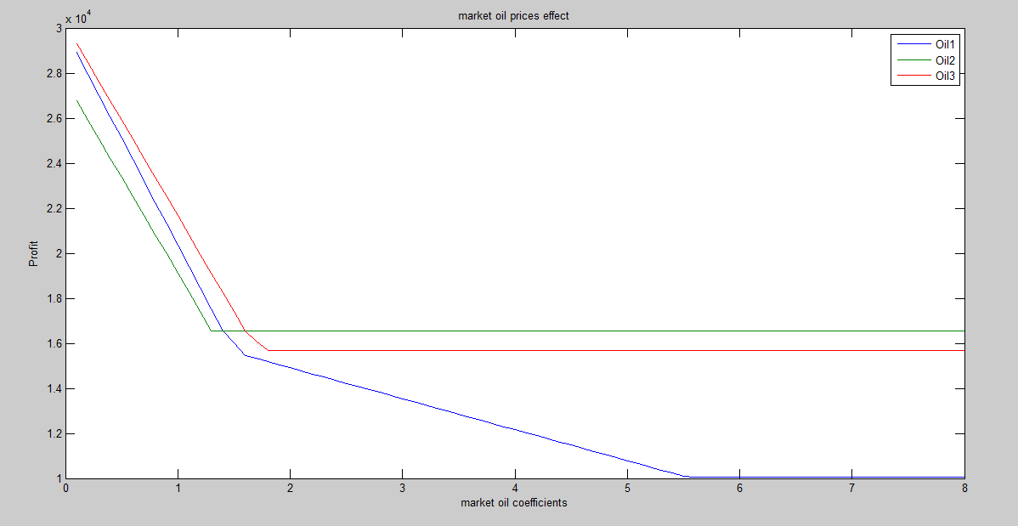

Oil1 effects profit to 10000 at least.

Oil2 effects profit to nearly 17000.

Oil3 effects profit to 16000.